PCB Annotation Help Sheet

*Drawing boxes*

* Make sure the bounding boxes encapsulate the entire component, including the pins that connect the component to the board itself. These may not present for all components.
* Leave a little bit of space between the edge of the component and the box, but not too much.
* Try not to have any overlapping bounding boxes; however, sometimes this is unavoidable.
* The types of components are: ic, capacitor, resistor, coil-inductor, fixed-inductor, ceramcap (ceramic capacitor)

*Examples of properly drawn boxes:*

ICs

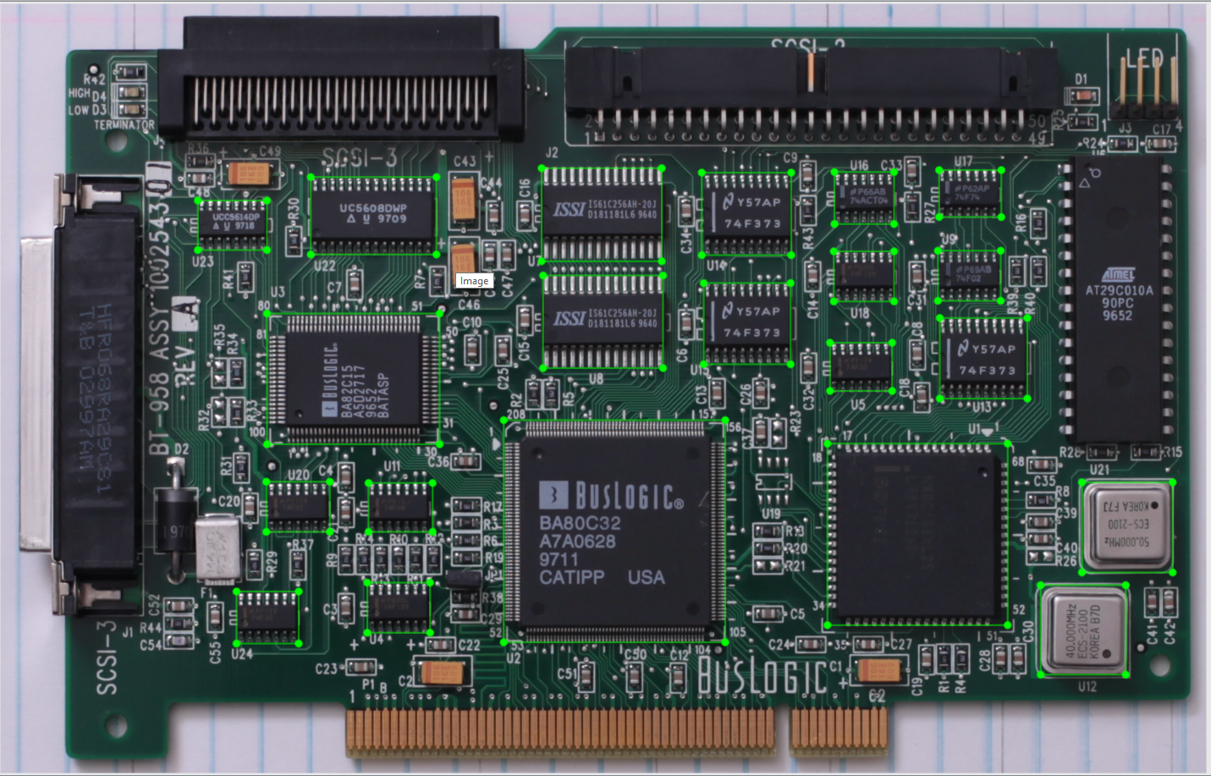

Note the pins are included!

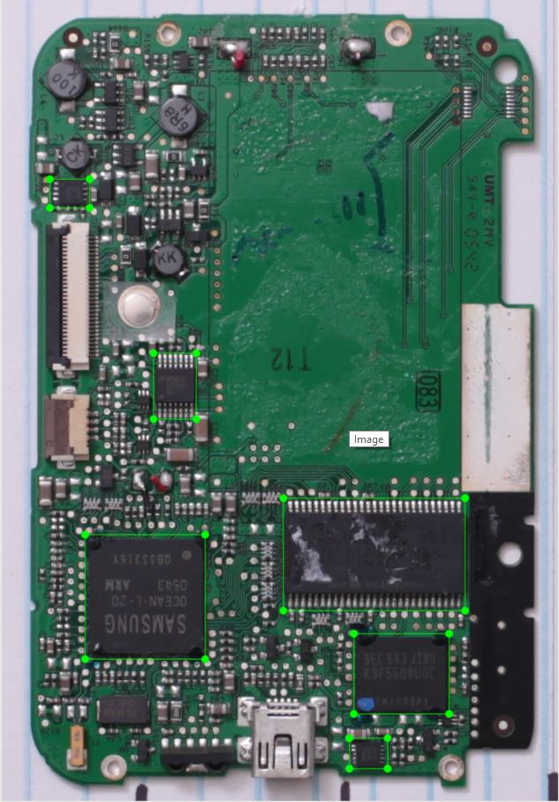

No pins here!

Capacitors

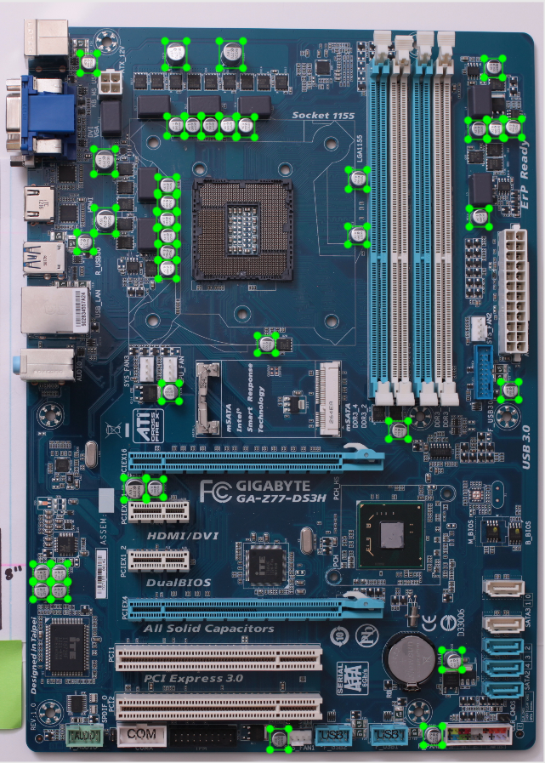

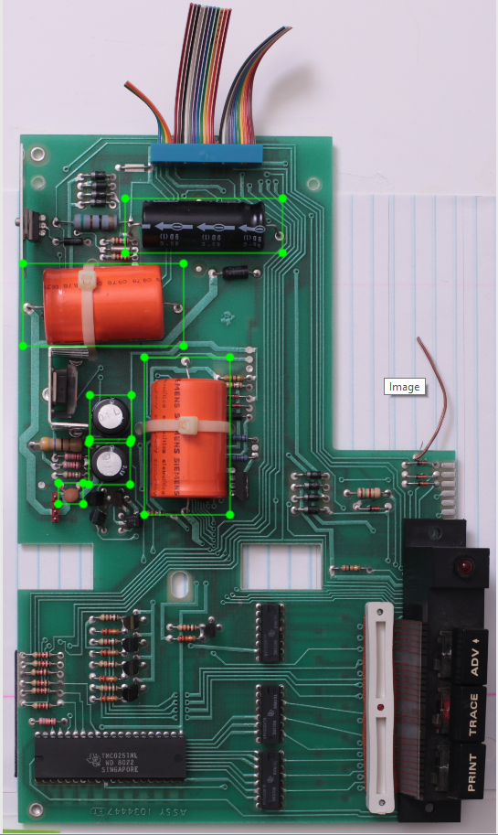

Note that the pins are included!

Resistors

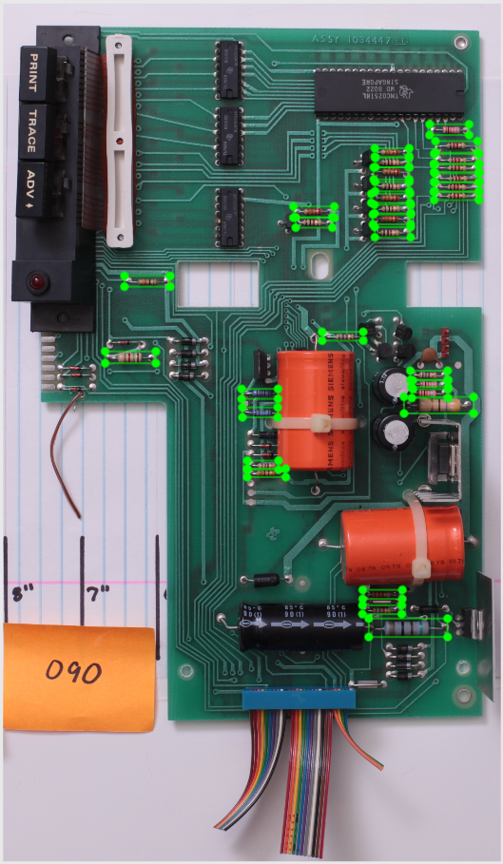

PINS!

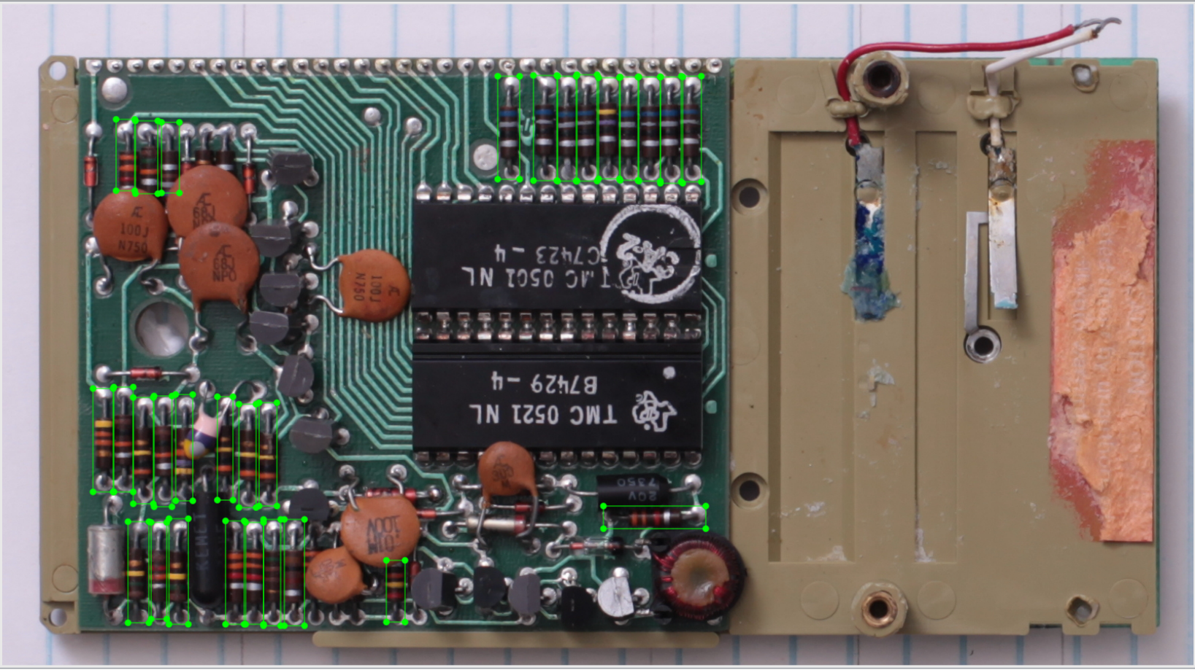

Component Lookup

|  |  |
| --- | --- |
| **Component** | **Images** |
| ic (Marked on board with ‘U’ |  |
| capacitor (Marked on board with ‘C’) |  |
| resistor (Marked on board with ‘R’) |  |
| sm-resistor (Surface mount) (Marked with ‘R’) |  |
| coil-inductor (Marked on board with ‘L’) |  |
| fixed-inductor (Marked with ‘L’) |  |
| ceramcap (Marked on board with ‘C’) |  |
| sm-cap (Marked with ‘C’) |  |